NATIONAL ASSOCIATION OF LEFT-HANDED GOLFERS
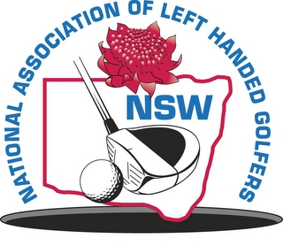
N.S.W. DIVISION INCORPORATED

PATRON
Doug Crosby OAM

PRESIDENT
Langdon Emery
CAPTAIN
Neal Loadsman

TREASURER
David Moffet
SECRETARY
John Mesley

LIFE MEMBERS:
Doug Crosby – OAM
Terry Lennox
John Kable
Don Harding

NEWSLETTER
January 2013

Happy new year to all!

We have enclosed with this newsletter four documents:
- Programme of events for the year.The final event at Avondale will be on either Wednesday 27th November or Wednesday 4th December.We will advise as soon as this is settled.
- Entry form for Moore Park.Shotgun start at 10 am Tuesday,5th February.
- Flier announcing the Mollydooker Challenge.New competition to be played throughout the year.
- Rules of the Mollydooker Challenge.

NSW State Titles.To be eligible to win the title it has been decided that a member must play in a minimum of two events in the period between the previous year’s championship and current one.This year the championship will be played at Ryde – Parramatta Golf Club on Thursday,19th September.

Orange Trip.The plan is to play Duntryleague in the afternoon of Wednesday 6th November (the day after %^&**# wins the Melbourne Cup) followed by Wentworth Golf Club in the late morning of Thursday 7th.We can confirm that the homeward bound game will be played at Lithgow Golf Club the morning of Friday 8th.A great trip enjoyed by all who have attended in the past.

Looking forward to a good year with the exciting addition of the Mollydooker Challenge to add a bit of extra interest.
Hope to see you at Moore Park.

John Mesley

