NATIONAL ASSOCIATION OF LEFT-HANDED GOLFERS
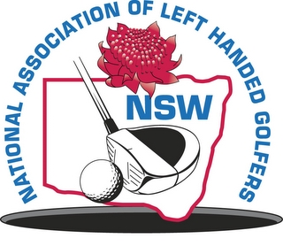
N.S.W. DIVISION INCORPORATED

PATRON
Doug Crosby OAM

PRESIDENT
Langdon Emery

CAPTAIN
Neal Loadsman
LIFE MEMBERS:
Doug Crosby – OAM
Terry Lennox
John Kable
Don Harding

application for membership

I,…………………………………….………………………………………………………………………
(full name of applicant)

Address………………………………………………………………………………Post Code…….……
(address)

Tele: Home.………..……….……Business……………….………Mobile….............……………………

Email:…………………………………………….…………………………………………………………

Hereby apply to become a member of the abovementioned incorporated association. In the event of my admission as a member, I agree to be bound by the rules of the association for the time being in force.

I am a financial member of ……………………………………………………………………….Golf Club
(home club)

my current A.G.U. handicap is and my Golf Link Number is

The sum of $ 25.00 is enclosed representing the current joining/membership fee.

…………………………………………………. …………………
Signature Date

I………………………………………………………………being a financial member of the association

nominate the applicant, who is personally known to me, for membership of the association.

……………………………………............................. ………………………………..…
Signature Date

